**CLOUD**

* Before cloud technology, infrastructure was a being challenge. During peak usage buy more infrastructure to handle peak load, but during less load still paying same amount for infrastructure as that of peak load.

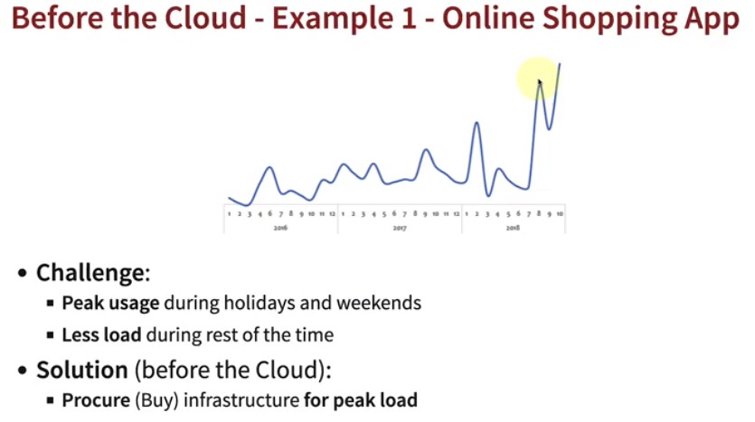

* Needed to determine peak usage ahead. Low infrastructure utilization. Dedicate maintenance team for infrastructure needed, usually difficult for startups to afford.

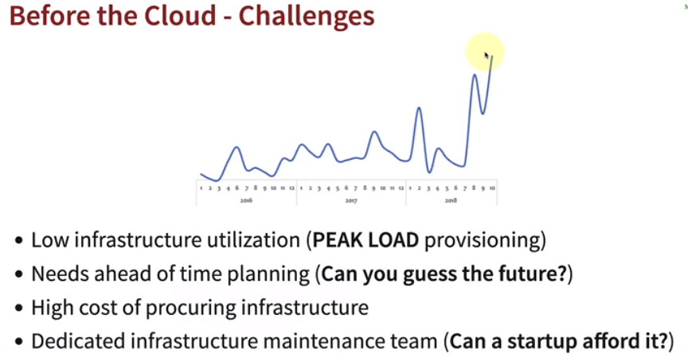

* Cloud introduced the concept of provisioning or renting resources, when we want more resources during peak usage we can get it and also release them back when we need less resources.

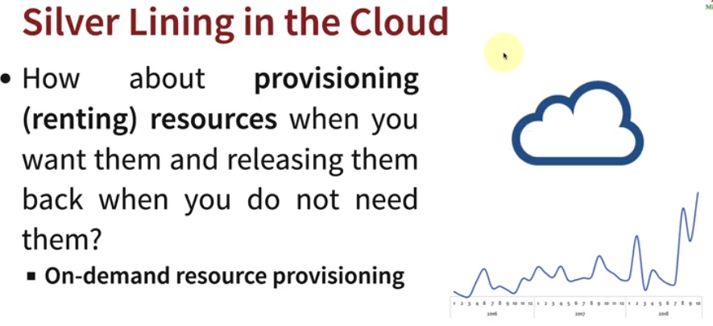

* **Advantages of cloud:**
  + Capital expense to variable expense (Pay per usage).
  + Getting application global in minutes.
  + Massive economies scale.
  + Avoid undifferentiated heavy lifting.
  + Cost saving in terms of maintaining data centers.

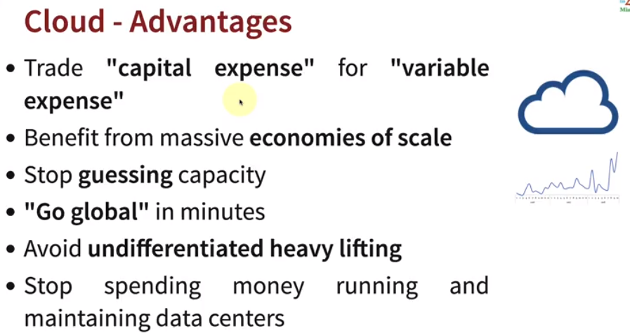

* **AWS (Amazon Web Services):** One of the leading cloud service provider with 200+ services, reliable, secure and cost-effective.
  + Competitors: Microsoft Azure and Google Cloud.

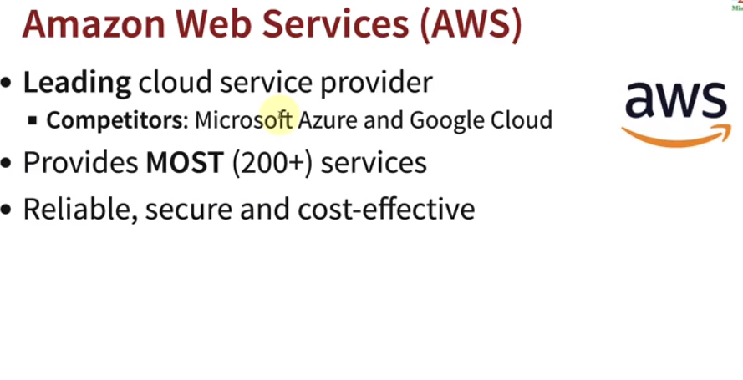

* All AWS services are interconnected, but in terms learning there is no fix path.

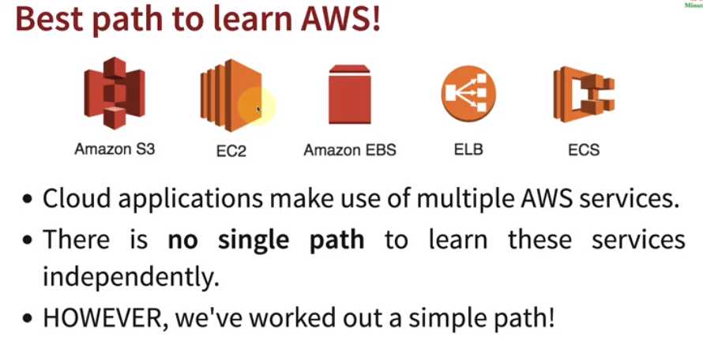

* **Link to create free tier AWS account:** [*https://aws.amazon.com/free*](https://aws.amazon.com/free)
* **Creating an IAM user:** Since the account created by us has root access, it is not recommended to use root user, instead we can create an IAM user and user group with admin access.

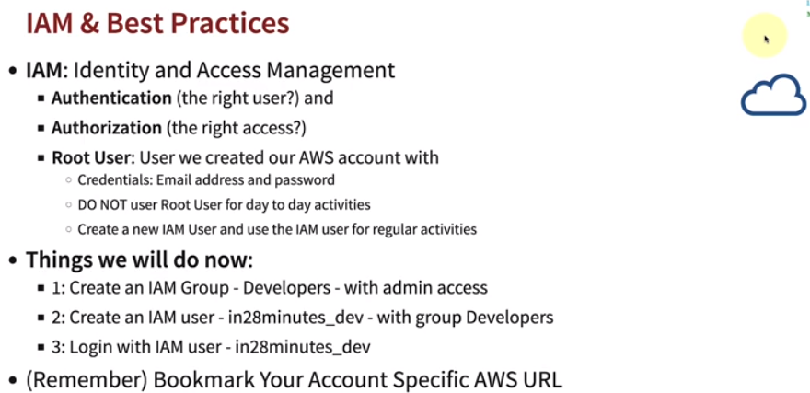

* + *Steps:*
    - *Search for IAM in management console.*

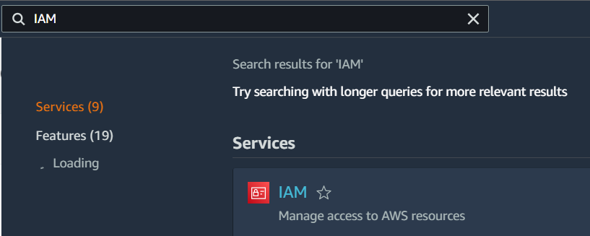

* + - *Select user groups, to create new User group first.*

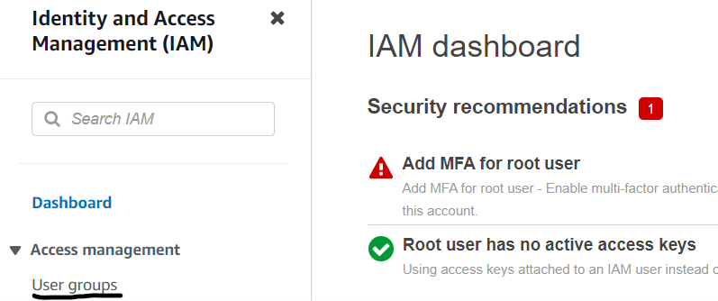

* + - *Create group.*

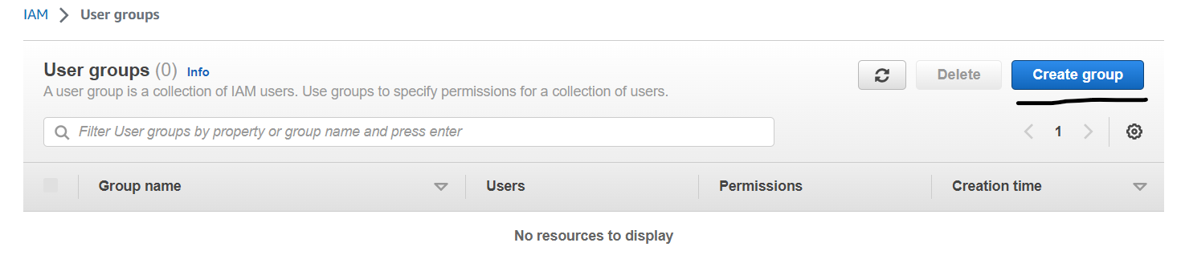

* + - *Enter group name.*

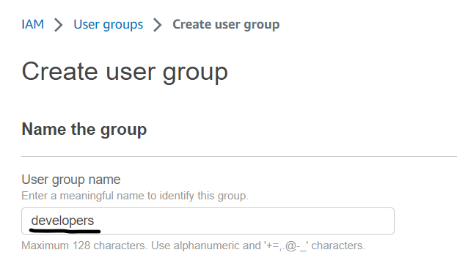

* + - *Select access level 🡪 Create group.*

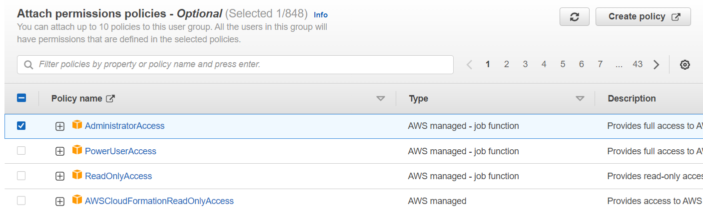

* + - *Once group created select 🡪 Users in IAM, to create new User.*

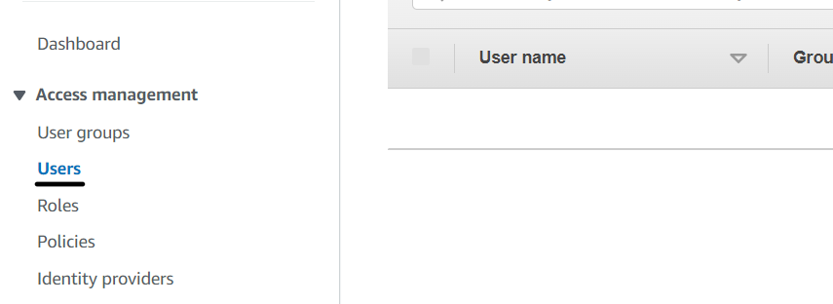

* + - *Specify new user details 🡪 Enter username 🡪 Custom or auto-generated password 🡪 Provide access to console or not 🡪 Next.*

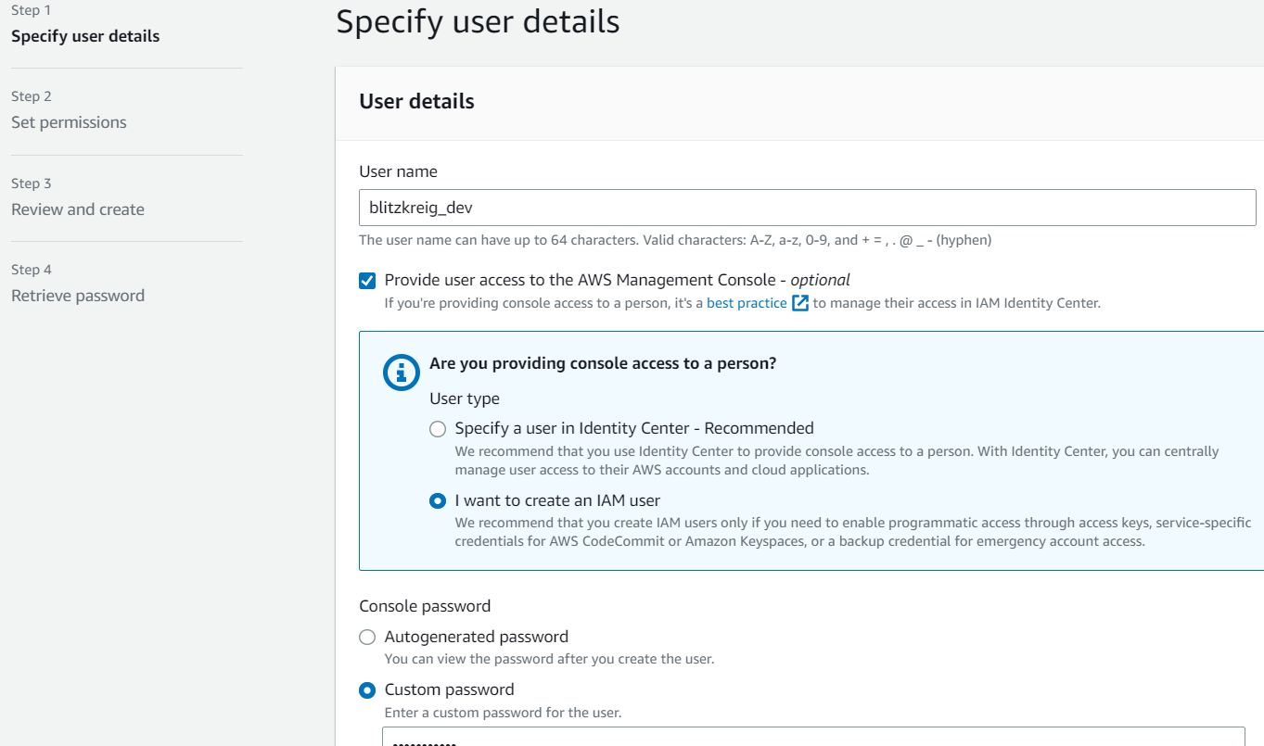

* + - *Assign user to a group 🡪 Select group 🡪 Next 🡪 Review 🡪 Create User.*

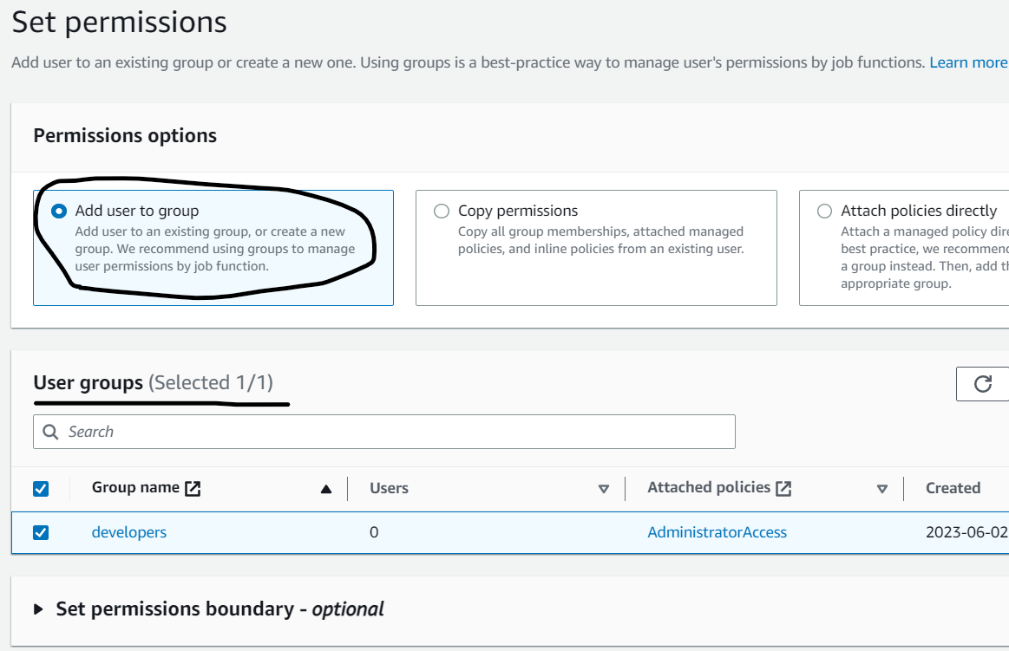

* + - *Now go to IAM 🡪 Dashboard and copy url 🡪 Use this url to signin with new user.*

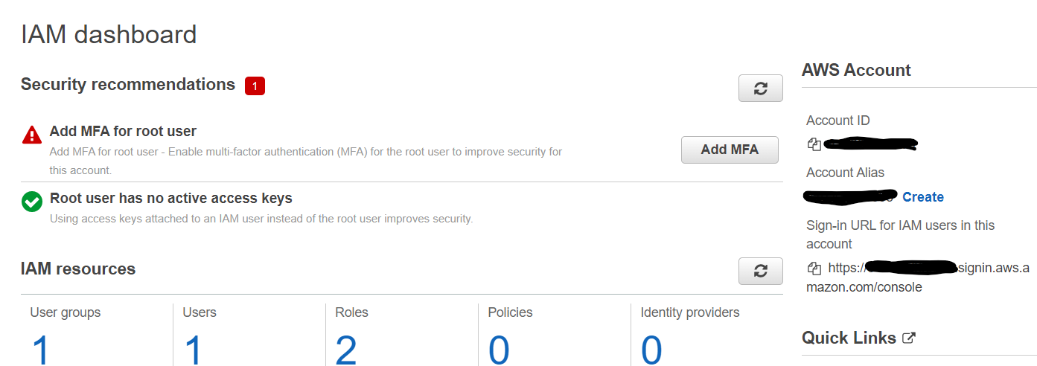

* **Regions and Zones:**
  + In this scenario what happens if application is deployed in one data center and that data center goes in unavailable state, application will go down as well. But in case the application is globally used then users apart from near to data center might face huge latency.

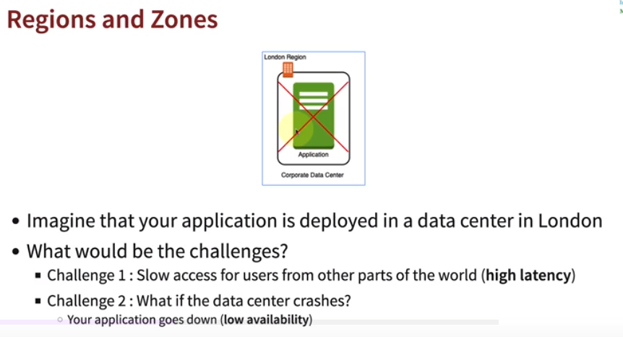

* + Let’s say we add new data center in same place, but this will only solve the issue with application availability. What if whole region goes down somehow?

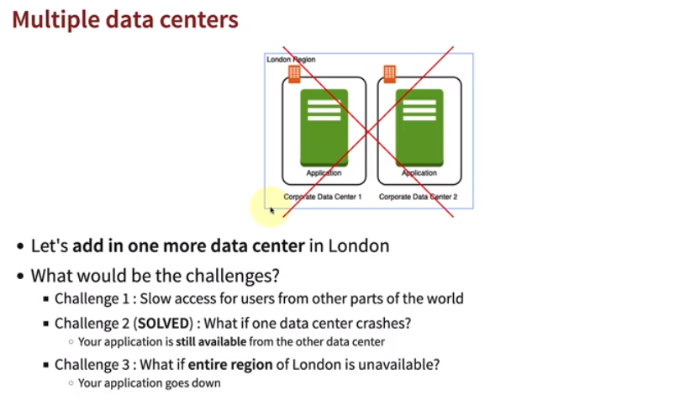

* + Hence need to deploy application in different regions, to reduce latency and increase availability, adding region and zones helps in the same.

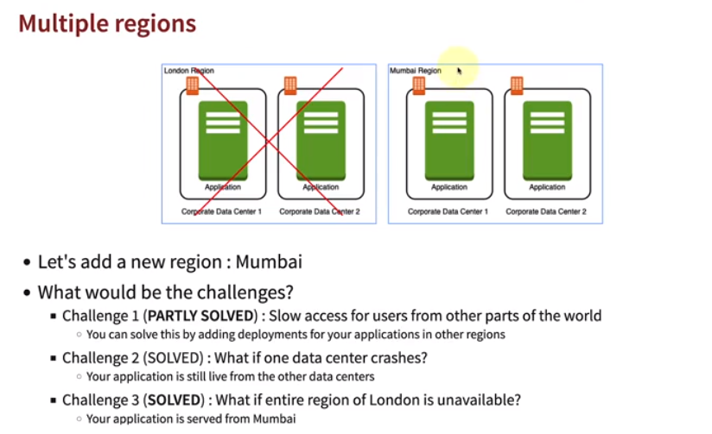

* + *AWS* provides 25+ regions and increasing day by day, this solves the problem for global availability.

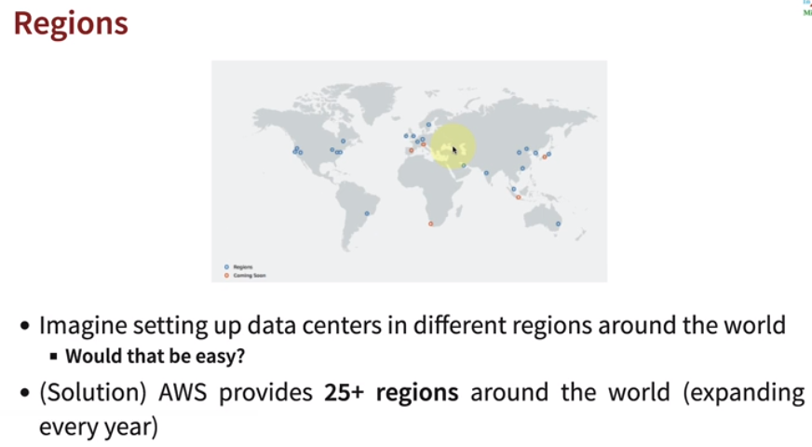

* + *Advantages for different regions:*
    - High availability of application.
    - Low latency almost everywhere.
    - Global reachability of application increases.
    - Adhere to government regulations, i.e., let’s say if America wants to keep data in their country as per government policy. So we can keep data in America region and run application from different region.

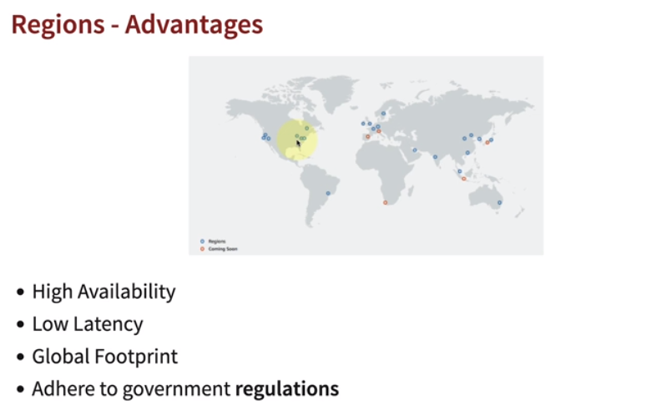

* + *AWS* region consists of multiple zones, have high availability. They have low latency links and increase availability of applications and fault tolerance.

